Table 1. Clinical information of syphilitic patients with Peripheral blood mononuclear cell sequenced
Diagnosis | Sex | Age | Course of disease | RPR Titer
Secondary syphilis | Male | 20-24 | 2 weeks | ≥1:32
Secondary syphilis | Famale | 30-34 | 2 months | ≥1:32
Secondary syphilis | Male | 25-39 | 1 month | ≥1:32
Secondary syphilis | Famale | 30-34 | 2 weeks | ≥1:32
Secondary syphilis | Male | 45-50 | 1 month | ≥1:32
Serofast status | Male | 50-54 | 3 years* | 1:8
Serofast status | Famale | 20-24 | 1.5 years* | 1:16
Serofast status | Famale | 30-34 | 1.5 years* | 1:16
Serofast status | Famale | 20-24 | 2 years* | 1:4
Serofast status | Famale | 35-39 | 2 years* | 1:8
Health control | Male | 20-24 | NA | NA
Health control | Famale | 45-50 | NA | NA
Health control | Male | 45-50 | NA | NA
Health control | Male | 30-34 | NA | NA
Health control | Female | 30-34 | NA | NA
: Rapid plasma regain
*: Secondary syphilis patients that had a ≥ 4-fold decline in their serum RPR titer after the recommended treatment, but showed no seroreversion or any decline in RPR titers for more than 1.5-3 years.
NA: Not applicable

Table 2. KEGG pathway enrichment of target genes of different expressed miRNAs
 |  | Function | KEGG pathway | p-Value
Secondary syphilis vs. Healthy control | Up in secondary syphilis | Circadian entrainment | hsa04713 | 0.010
Secondary syphilis vs. Healthy control | Up in secondary syphilis | Glioma | hsa05214 | 0.036
Secondary syphilis vs. Healthy control | Down in secondary syphilis | Histidine metabolism | hsa00340 | 0.010
Secondary syphilis vs. Healthy control | Down in secondary syphilis | Fructose and mannose metabolism | hsa00051 | 0.030
Secondary syphilis vs. Healthy control | Down in secondary syphilis | Hippo signaling pathway | hsa04390 | 0.042
Secondary syphilis vs. Healthy control | Down in secondary syphilis | T cell receptor signaling pathway | hsa04660 | 0.044
Serofast status vs. Healthy control | Up in serofast status | Transcriptional misregulation in cancer | hsa05202 | 0.020
Serofast status vs. Healthy control | Up in serofast status | HTLV-I infection | hsa05166 | 0.025
Serofast status vs. Healthy control | Up in serofast status | Circadian entrainment | hsa04713 | 0.035
Serofast status vs. Healthy control | Up in serofast status | Fat digestion and absorption | hsa04975 | 0.039
Serofast status vs. Healthy control | Up in serofast status | Viral myocarditis | hsa05416 | 0.045
Serofast status vs. Healthy control | Down in serofast status | Vascular smooth muscle contraction | hsa04270 | 0.018
Serofast status vs. Healthy control | Down in serofast status | Tyrosine metabolism | hsa00350 | 0.029
Serofast status vs. Healthy control | Down in serofast status | Fat digestion and absorption | hsa04975 | 0.033
Serofast status vs. Healthy control | Down in serofast status | Sphingolipid metabolism | hsa00600 | 0.043
Serofast status vs. Healthy control | Down in serofast status | Ether lipid metabolism | hsa00565 | 0.045
Serofast status vs. Secondary syphilis | Up in serofast status | Neurotrophin signaling pathway | hsa04722 | 0.018
Serofast status vs. Secondary syphilis | Up in serofast status | Calcium signaling pathway | hsa04020 | 0.031
Serofast status vs. Secondary syphilis | Up in serofast status | Nicotine addiction | hsa05033 | 0.036
Serofast status vs. Secondary syphilis | Up in serofast status | Alzheimer's disease | hsa05010 | 0.049
Serofast status vs. Secondary syphilis | Down in serofast status | Phosphatidylinositol signaling system | hsa04070 | 0.031
Serofast status vs. Secondary syphilis | Down in serofast status | Histidine metabolism | hsa00340 | 0.039
Serofast status vs. Secondary syphilis | Down in serofast status | Insulin signaling pathway | hsa04910 | 0.042
Serofast status vs. Secondary syphilis | Down in serofast status | Adipocytokine signaling pathway | hsa04920 | 0.045
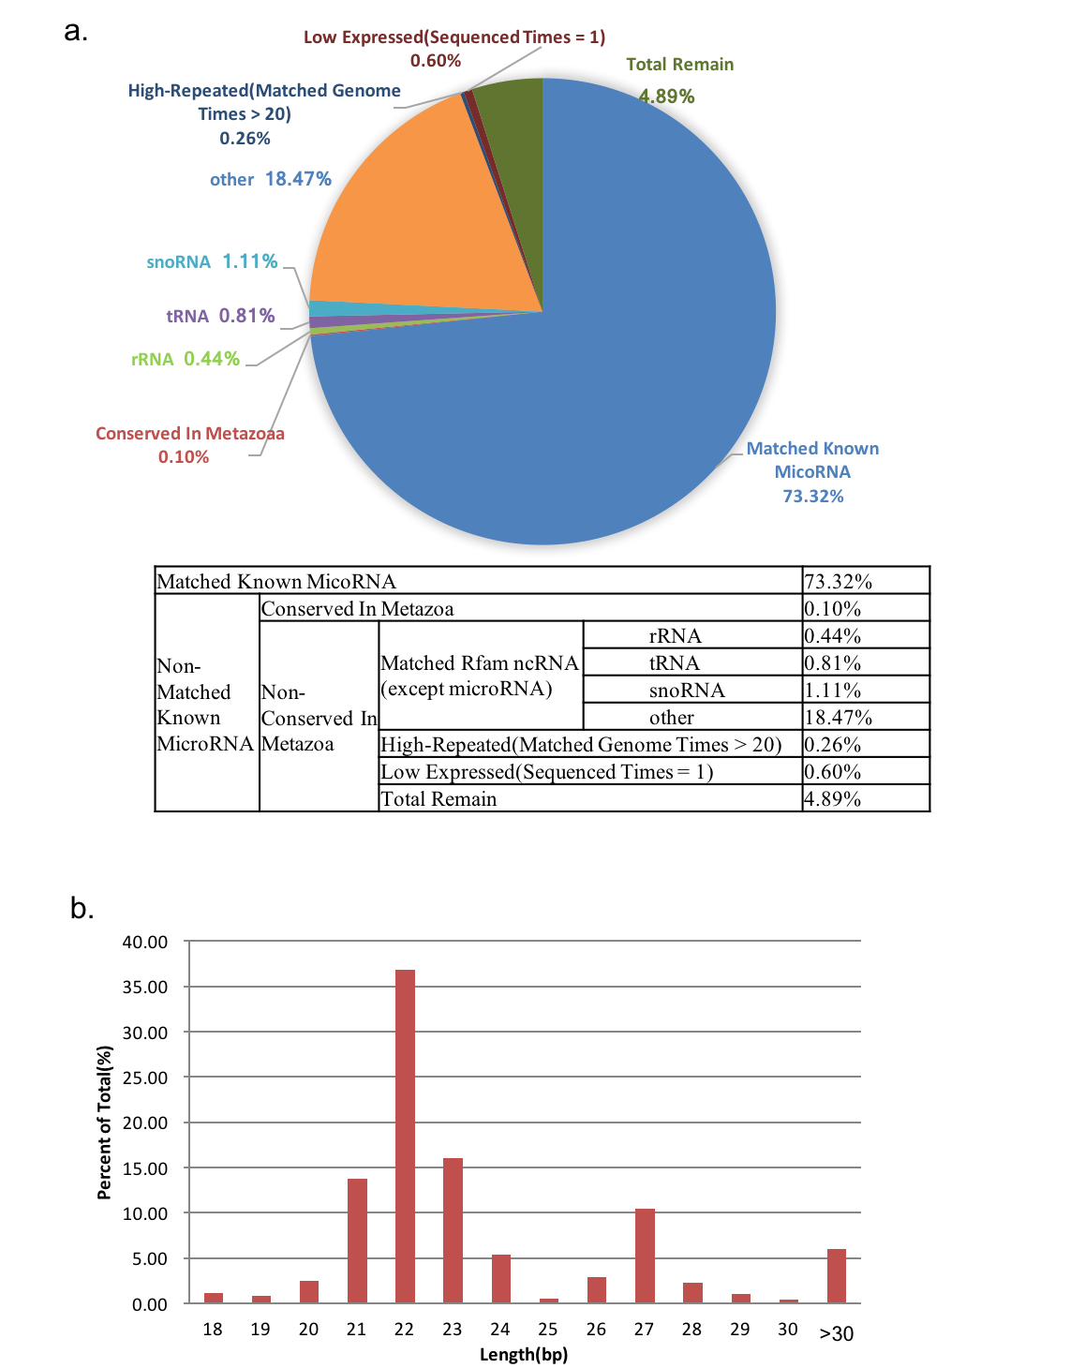
Fig. 1
Fig. 1. Distribution of miRNA sequencing reads. a. Distribution ration of miRNA sequencing reads. b. Length distribution of miRNA sequencing reads.

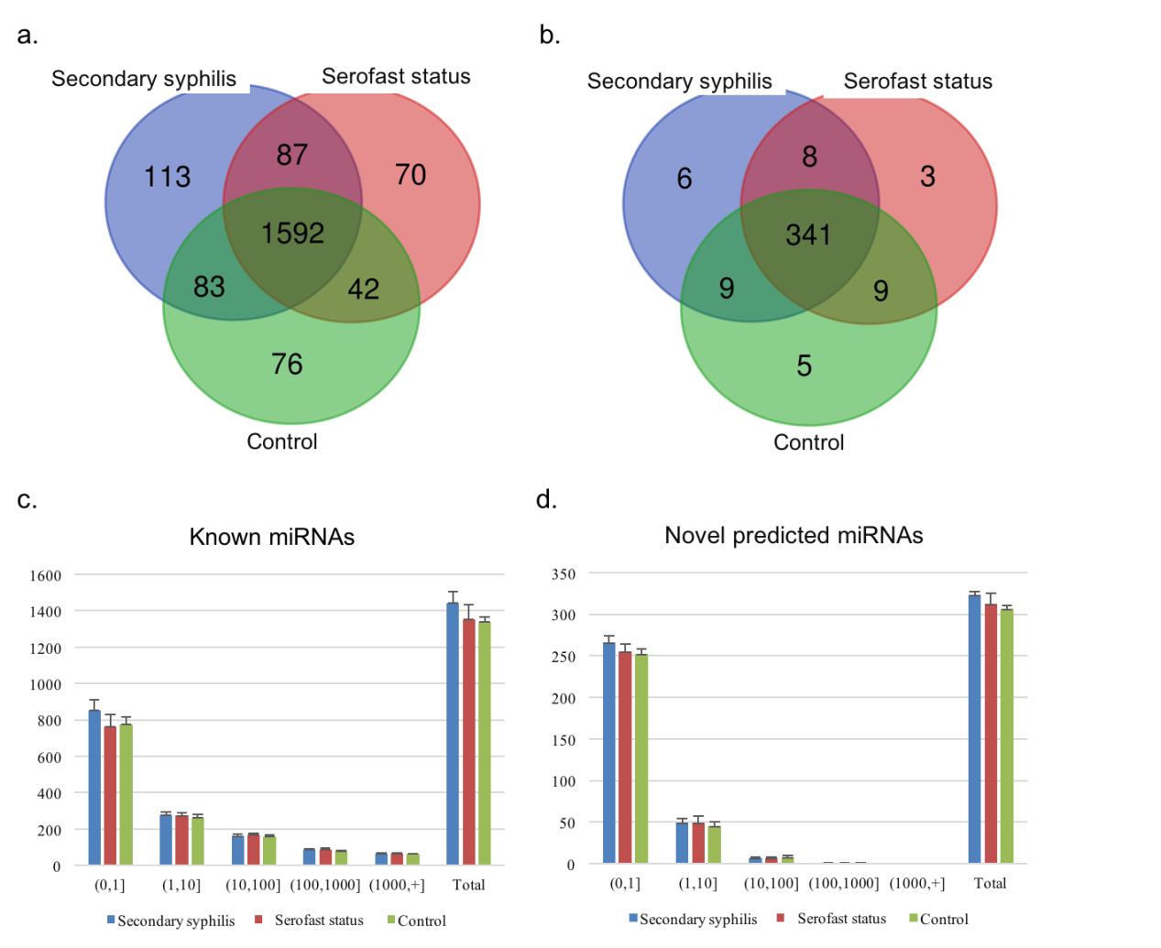
Fig. 2
Fig. 2. Global miRNA expression profiles. a. Overlaps of expressed (TPM > 0) known miRNAs. b. Overlaps of expressed (TPM > 0) novel predicted miRNAs. c. Distribution of known miRNA expression levels. X axis was divided into six parts by five expression levels and the sixth total expression counts. Y axis indicated TPM of miRNAs according to expression levels. d. Distribution of novel predicted miRNA expression levels. X axis was divided into six parts by five expression levels and the sixth total expression counts. Y axis indicated TPM of miRNAs according to expression levels.

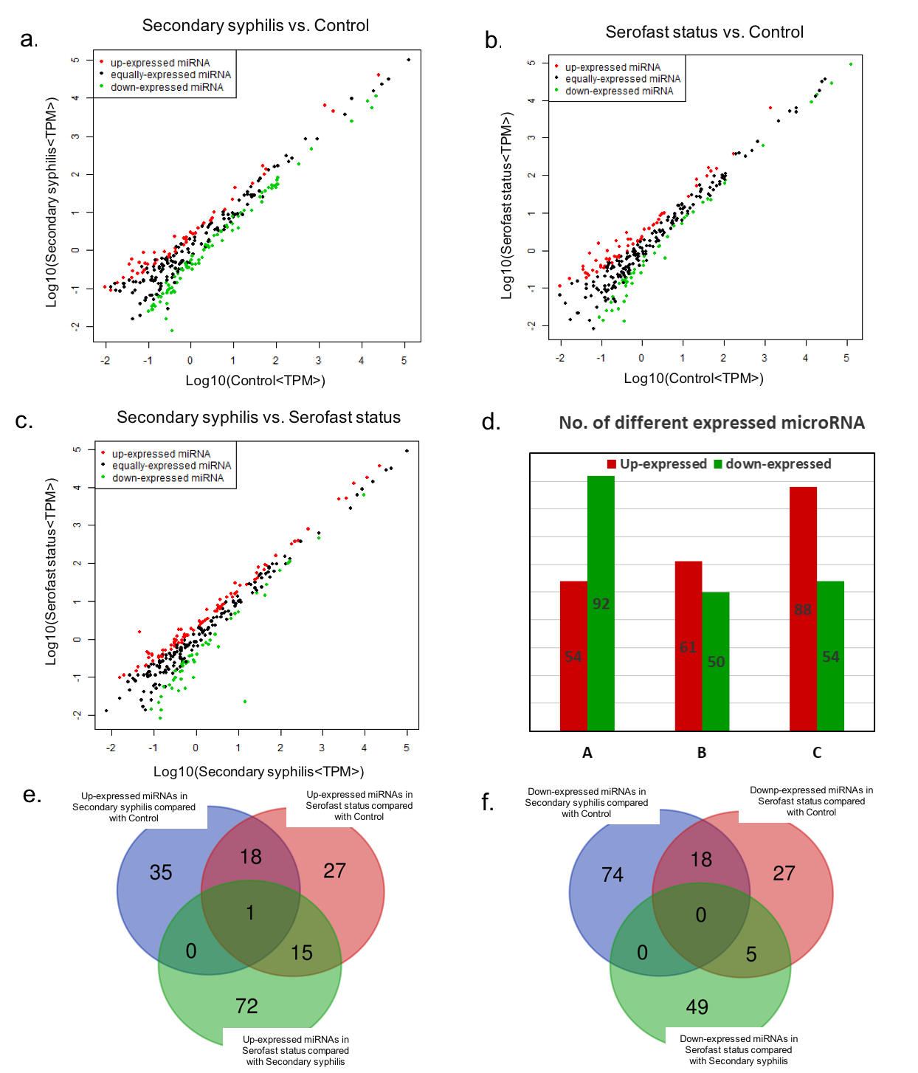
Fig. 3
Fig. 3. Different expressed miRNAs. a. Different expressed miRNAs between secondary syphilis and health control. Up-expressed miRNAs in secondary syphilis were shown as red dots, and down-expressed ones were marked as green dots. b. Different expressed miRNAs between serofast status and health control. Up-expressed miRNAs in serofast status were shown as red dots, and down-expressed ones were marked as green dots. c. Different expressed miRNAs between serofast status and secondary syphilis. Up-expressed miRNAs in serofast status were shown as red dots, and down-expressed ones were marked as green dots. d. Number of different expressed miRNAs corresponding to figure 3a, figure 3b and figure 3c. “A” represents different expressed miRNAs between secondary syphilis and health control in figure 3a. “B” represents different expressed miRNAs between serofast status and health control in figure 3b. “C” represents different expressed miRNAs between serofast status and secondary syphilis in figure 3c. “Red” and “green” have the same meanings with that in figure 3a, figure 3b and figure 3c, respectively. e. Overlaps of up-expressed miRNAs. f. Overlaps of down-expressed miRNAs.

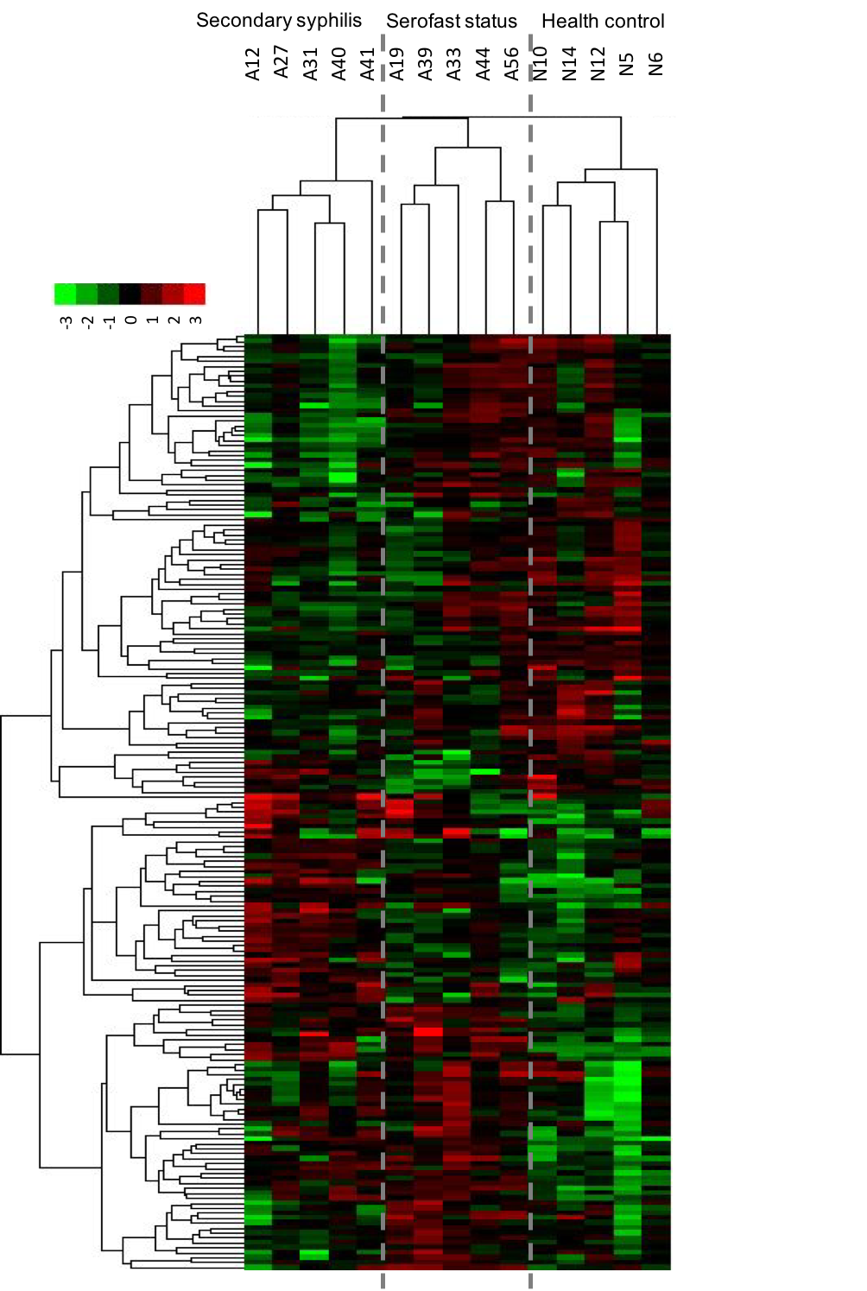
Fig. 4
Fig. 4. Hierarchical clustering of different expressed miRNAs among three groups.

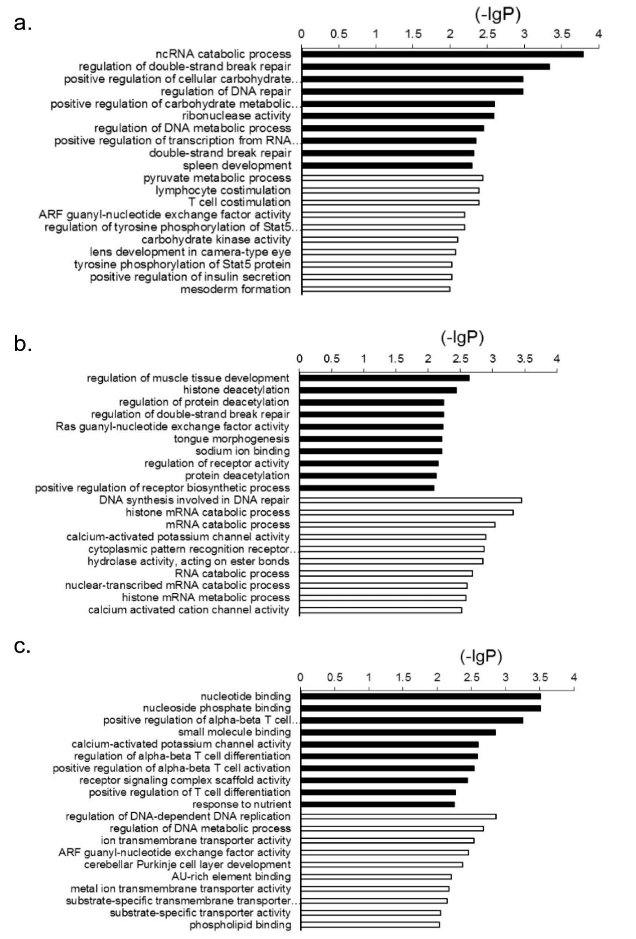
Fig. 5
Fig. 5. Top 10 GO function enriched terms of target genes of different expressed miRNAs. a. secondary syphilis vs. health control. b. serofast status vs. health control. c. serofast status vs. secondary syphilis. Black bars represent the target genes of up-regulated miRNAs in the former group, and white bars means the target genes of down-regulated miRNAs in the former group.

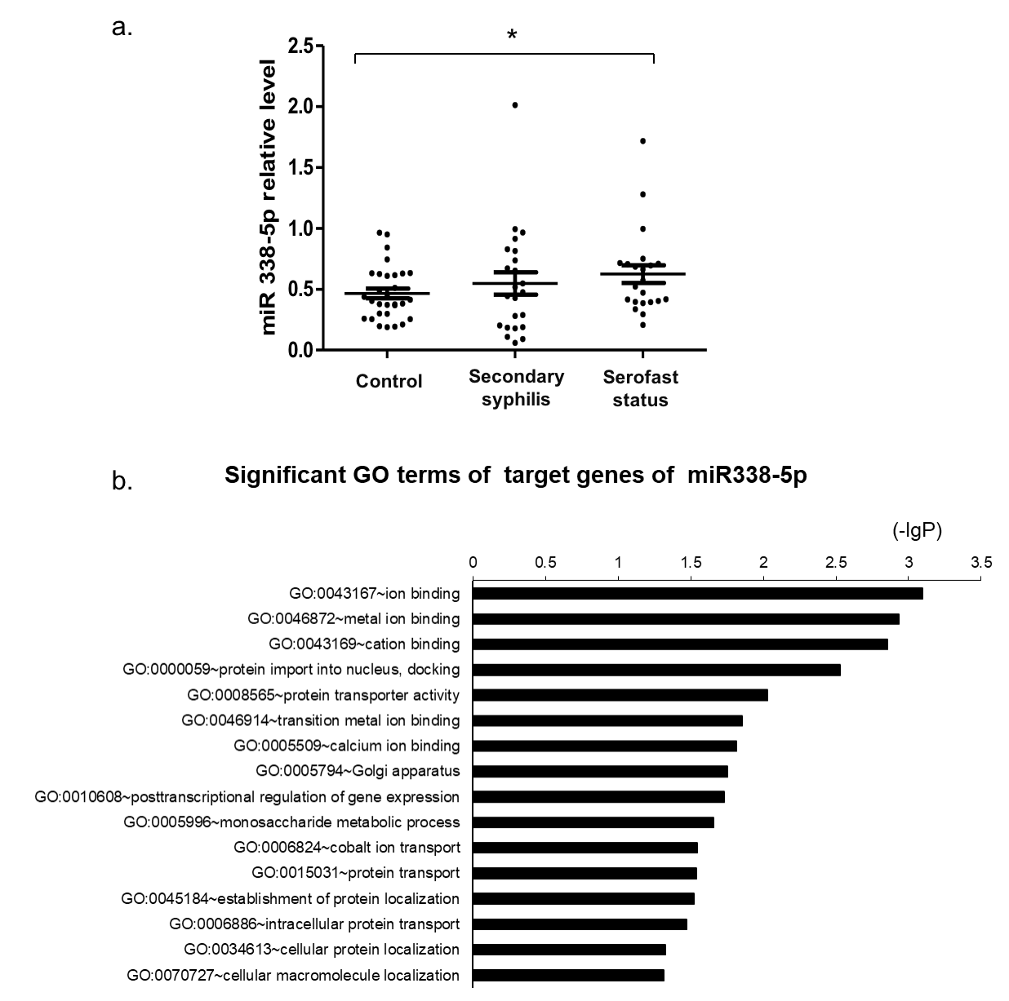
Fig. 6
Fig. 6. Expression levels and significant GO terms of target genes of miR-338-5p. a. Expression level (qPCR) of miR-338-5p in three groups (p <0.05, *). b. Significant GO terms of target genes of miR-338-5p.

Additional file

Table S1 Sequenced reads in 15 libraries
Class | High-quality readsª | Total of perfect  matched reads^{b} | %
A12 | 32345964 | 26956377 | 83.34
A19 | 19857857 | 16337577 | 82.27
A27 | 27704315 | 22192226 | 80.10
A31 | 34945154 | 27147048 | 77.68
A33 | 33849198 | 25648877 | 75.77
A39 | 20093413 | 14883247 | 74.07
A40 | 32561958 | 25603452 | 78.63
A41 | 22769799 | 18417745 | 80.89
A44 | 19625544 | 15946048 | 81.25
A56 | 23100930 | 16863448 | 73.00
N10 | 21453571 | 16157008 | 75.31
N12 | 25658467 | 16888422 | 65.82
N14 | 31789942 | 24473341 | 76.98
N5 | 26970532 | 22002880 | 81.58
N6 | 27972294 | 23506961 | 84.04
Average | 26713263 | 20868310 | 78.05
ªHigh quality reads: more than 70% bases with quality >=20; ^{b}Perfect matched reads: 100% matched to reference genome

Table S2 Forward primers used in qPCR assays.
Name | Sequence (5’-> 3’)
U6 | AATTGGAACGATACAGAGAAG
miR-10b-5p | TACCCTGTAGAACCGAATTTGTG
miR-3135b | GGCTGGTCCGAGTGCAGT
miR-122-5p | TGGAGTGTGACAATGGTGTTTG
miR-299-3p | TATGTGGGATGGTAAACCGCTT
miR-451a | AAACCGTTACCATTACTGAGTT
miR-548ar-3p | TAAAACTGCAGTTATTTTTGC
miR-548av-3p | AAAACTGCAGTTACTTTTGC
miR-548az | AAAGTAATTGTGGTTTCTGCCA
miR-548j-3p | CAAAAACTGCATTACTTTTGC
miR-654-5p | TGGTGGGCCGCAGAACATGTGC
miR-1285f | TCTGGGCAACAAAGTGAGAA
miR-2478c | ATCTCACTTCTGACACCA
miR-3150b-3p | TGAGGAGATCGTCGAGGTTGG
miR-338-5p | AACAATATCCTGGTGCTGAGTG
miR-3897 | GTGGTGGTGGTGGGGGGG
miR-4732-3p | GCCCTGACCTGTCCTGTTCTG
Novel-5 | TCCCCAGCATCTCCACCA
Novel-73 | GAGACCCGAGGTAGGGCTTTGGCTG
Novel-124 | CTGTGCCTGGCCTGGGGAGC
Novel-128 | CCTGTCCCCGCCGGCGGGCCGCCC
Novel-163 | CGGCCTTCGCGAGCGTCTGGGC
Novel-66 | TCCGGATCCGGCTCCGCGCCT
Novel-194 | CCGCCCTACCCCCCCGGCCCC
Novel-244 | ACCGAAGTGCTGACAGAAC
Novel-194* | CCGCCCTACCCCCCCGGCCCC

Table S3. Expression levels of miRNAs by qRCP
miRNA | Health control (n=5) | Secondary syphilis (n=5) | Serofast status (n=5)
miR10b | 1.375±0.616 | 1.656±0.759 | 1.364±0.632
miR62 | 0.153±0.026 | 0.081±0.008* | 0.130±0.132
miR122 | 0.218±0.089 | 0.144±0.084 | 0.155±0.118
miR299 | 0.089±0.072 | 0.157±0.104 | 0.240±0.112*
miR451a | 195.310±88.307 | 354.272±294.423 | 693.200±389.406*
miR548ar3p | 0.059±0.046 | 0.066±0.094 | 0.044±0.025
miR548av3p | 0.093±0.064 | 0.032±0.014 | 0.081±0.061
miR548az | 0.150±0.052 | 0.267±0.110 | 0.211±0.054
miR548j | 0.120±0.063 | 0.079±0.057 | 0.297±0.240*
miR654 | 0.231±0.141 | 0.357±0.169 | 0.560±0.204*
miR1285f | 0.174±0.065 | 0.215±0.139 | 0.264±0.121
miR2478 | 41.018±18.491 | 32.347±17.076 | 59.954±27.228
miR3135b | 2952.097±668.901 | 2025.312±238.754* | 2978.019±1619.808
miR3150b | 0.060±0.025 | 0.049±0.006 | 0.048±0.011
miR338-5p | 0.999±0.348 | 3.377±1.596* | 1.854±0.537*
miR3897 | 0.332±0.100 | 0.433±0.064 | 0.433±0.104
miR4732 | 0.053±0.015 | 0.040±0.039 | 0.037±0.026
np-miR5 | 269.088±87.545 | 771.539±296.133* | 837.256±342.287*
np-miR73 | 14.774±3.823 | 9.990±5.085 | 5.053±4.021*
np-miR124 | 2.597±0.618 | 2.246±1.238 | 1.130±0.670*
np-miR128 | 171.813±63.068 | 89.236±32.771* | 74.036±38.172*
np-miR163 | 3.029±0.581 | 0.925±0.316* | 1.964±0.968*
np-miR166 | 0.371±0.242 | 0.113±0.055* | 0.305±0.220
np-miR194 | 288.352±109.301 | 222.104±161.149 | 222.223±117.319
np-miR244 | 0.408±0.067 | 0.283±0.230 | 0.150±0.075*

Table S4. Expression levels of miRNAs by qPCR with large samples
miRNA | Health control (n=40) | Secondary syphilis (n=23) | Serofast status(n=22)
miR299 | 0.066±0.044 | 0.083±0.052 | 0.066±0.056
miR451a | 220.97±185.975 | 283.15±179.159 | 204.21±182.441
miR548j | 0.090±0.107 | 0.125±0.119 | 0.090±0.077
miR654 | 0.124±0.102 | 0.102±0.087 | 0.160±0.1662
miR338-5p | 0.466±0.218 | 0.547±0.436 | 0.624±0.346*
np-miR5 | 168.83±128.620 | 251.71±160.566* | 201.55±138.307
np-miR73 | 3.160±2.915 | 3.622±3.402 | 3.616±3.431
np-miR124 | 0.943±0.665 | 0.822±0.513 | 0.759±0.595
np-miR128 | 65.477±46.852 | 30.7852±21.614* | 37.360±35.219*
np-miR163 | 0.796±0.571 | 0.545±0.332* | 0.613±0.382
np-miR244 | 0.182±0.130 | 0.097±0.063* | 0.119±0.089*

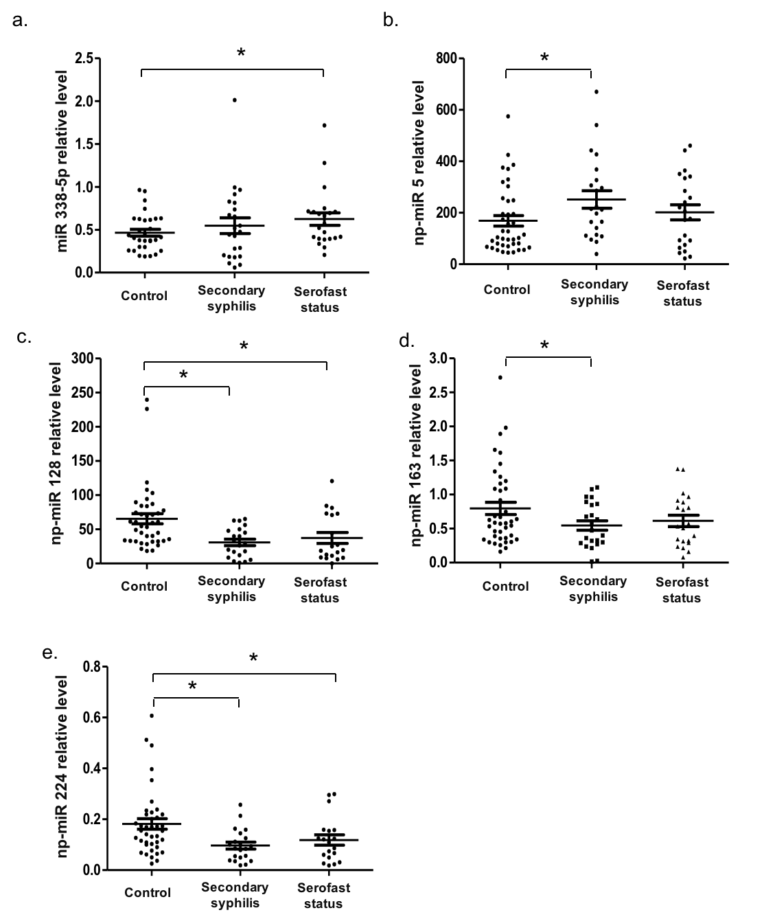
Fig. S1
Fig. S1. Expression levels of different expressed miRNAs validated by qPCR with large samples in three groups (p <0.05, *).

